NEERS Membership Numbers

Total Membership
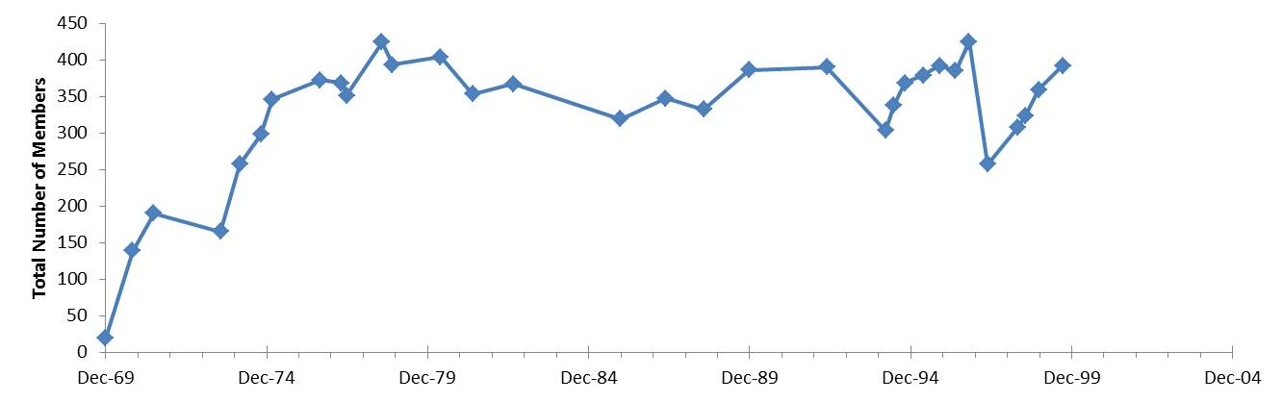

Membership by Region
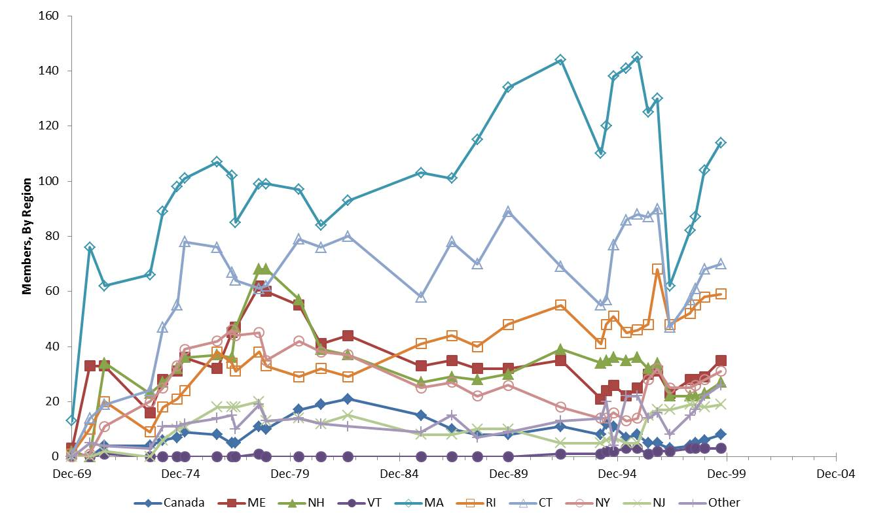

Membership Totals and Membership by Region
These are the data used in plots above.
Date | Total | Canada | ME | NH | VT | MA | RI | CT | NY | NJ
Fall, 1969 | 20 | 0 | 3 | 2 | 0 | 13 | 1 | 1 | 0 | 0
Fall, 1970 | 139 | 0 | 33 | 0 | 0 | 76 | 10 | 14 | 1 | 0
Spring, 1971 | 190 | 4 | 33 | 34 | 1 | 62 | 20 | 19 | 11 | 2
Fall, 1973 | 165 | 4 | 16 | 23 | 0 | 66 | 9 | 24 | 20 | 0
Spring, 1974 | 257 | 6 | 28 | 27 | 0 | 89 | 18 | 47 | 25 | 6
Fall, 1974 | 298 | 7 | 31 | 32 | 0 | 98 | 21 | 55 | 33 | 10
Spring, 1975 | 346 | 9 | 36 | 36 | 0 | 101 | 24 | 78 | 39 | 11
Fall, 1976 | 372 | 8 | 32 | 37 | 0 | 107 | 38 | 76 | 42 | 18
Spring, 1977 | 368 | 5 | 45 | 36 | 0 | 102 | 34 | 67 | 46 | 18
Spring, 1977 | 351 | 5 | 47 | 47 | 0 | 85 | 31 | 64 | 44 | 18
Fall, 1978 | 424 | 11 | 62 | 68 | 1 | 99 | 38 | 61 | 45 | 20
Fall, 1978 | 393 | 10 | 60 | 68 | 0 | 99 | 33 | 62 | 35 | 13
Spring, 1980 | 404 | 17 | 55 | 57 | 0 | 97 | 29 | 79 | 42 | 14
Spring, 1981 | 353 | 19 | 41 | 39 | 0 | 84 | 32 | 76 | 38 | 12
Fall, 1982 | 367 | 21 | 44 | 37 | 0 | 93 | 29 | 80 | 37 | 15
Fall, 1985 | 319 | 15 | 33 | 27 | 0 | 103 | 41 | 58 | 25 | 8
Spring, 1987 | 347 | 10 | 35 | 29 | 0 | 101 | 44 | 78 | 27 | 8
Fall, 1988 | 332 | 8 | 32 | 28 | 0 | 115 | 40 | 70 | 22 | 10
Fall, 1989 | 386 | 8 | 32 | 30 | 0 | 134 | 48 | 89 | 26 | 10
Spring, 1992 | 390 | 11 | 35 | 39 | 1 | 144 | 55 | 69 | 18 | 5
Spring, 1994 | 303 | 8 | 21 | 34 | 1 | 110 | 41 | 55 | 14 | 5
Spring, 1994 | 338 | 12 | 24 | 35 | 2 | 120 | 48 | 57 | 14 | 6
Fall, 1994 | 368 | 11 | 26 | 36 | 2 | 138 | 51 | 77 | 16 | 7
Spring, 1995 | 379 | 7 | 22 | 35 | 3 | 141 | 45 | 86 | 13 | 5
Fall, 1995 | 392 | 8 | 25 | 36 | 3 | 145 | 46 | 88 | 14 | 5
Spring, 1996 | 385 | 5 | 30 | 32 | 1 | 125 | 48 | 87 | 28 | 15
Fall, 1996 | 425 | 5 | 31 | 34 | 2 | 130 | 68 | 90 | 32 | 17
Spring, 1997 | 257 | 3 | 23 | 22 | 2 | 62 | 48 | 47 | 25 | 17
Spring, 1998 | 307 | 4 | 28 | 22 | 3 | 82 | 52 | 57 | 25 | 19
Fall, 1998 | 323 | 5 | 28 | 22 | 3 | 87 | 55 | 61 | 26 | 19
Fall, 1998 | 359 | 6 | 29 | 23 | 3 | 104 | 58 | 68 | 28 | 18
Fall, 1999 | 392 | 8 | 35 | 27 | 3 | 114 | 59 | 70 | 31 | 19

