NEERS Business Meeting minutes, 6/3/22

Present: Brett Branco, Courtney Schmidt, Sara Grady, Tay Evans, Claudia Mazur, Sue Adamowicz, Alan Young, Walter Berry, Tristan Taber, Peg Pelletier

- Approval of the minutes of last meeting
- Honorary Award presented to Sara Grady:
“Sara Grady has been the Mass Bays Program South Shore Regional Coordinator and the Watershed Ecologist of the North & South River Watershed Association since 2005, which is when she joined NEERS. At various times Sara has been (or still is) Secretary (2010-2014), President-Elect (2008-2010), President (2010-2012), Past-President (2012-2014), the Newsletter Editor (2008-present) and the organizer and leader of the NEERS band (forever). Sara has helped organize several NEERS meetings (Spring 2012 in Plymouth MA, Spring 2018 in Portsmouth, NH, Fall 2018 in New Bedford MA) as well as the Fall 2019 CERF meeting in Providence RI. Sara has attended virtually all NEERS meetings since becoming a member and is an active participant, giving oral presentations at several meetings. NEERS is pleased to present Sara Grady with an Honorary Membership in the Society.”
- Officer Reports
  - President (Brett Branco)
    - Sue Adamowicz will be recruiting for President-elect and Secretary – the 2 positions that will be up for election in Fall 22
    - Courtney Schmidt will become the President at the end of the Fall 22 meeting. At that time she will be responsible for appointing at-large members, the student rep, the Historian, and the Program Chairs
    - The President, President-Elect and Past-President will be working together to define the President’s initiative to address diversity, growing the membership and mentorship of NEERS
  - Past President (Sue Adamowicz) – no new business
  - President-Elect (Courtney Schmidt)
    - CERF Governing Board: New Strategic Plan will focus on diversification and expansion of the membership
    - A new Program chair – Holly Plaisted worked to coordinate the poster session
    - Looking for a student or social-media savvy NEERS member to take over our social media accounts and post content
    - President’s Initiative will be discussed further tomorrow
  - Treasurer (Tristan Taber)
    - Account balances:
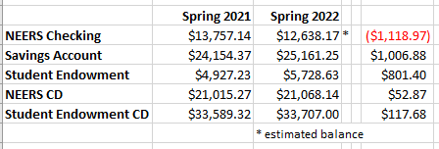
    - Sponsors
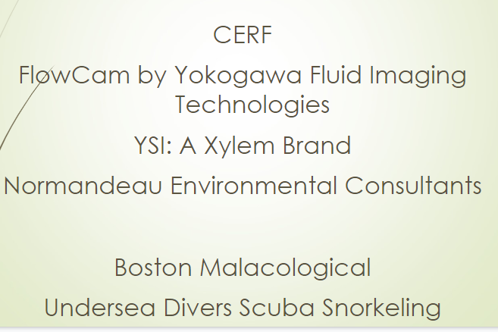
  - Secretary (Peg Pelletier) – term is up at the end of the Fall meeting, so please talk to her if you have interest in learning about what the position requires
- Committee Reports
    - Webmasters – Jamie and Savannah not at the meeting, but Savannah did a lot of work setting up for the meeting and Jamie and Alan are working on transferring the neers.org website to wild apricot.
    - Newsletter (Sara Grady) – she would like to put it out 2x/year so she may be asking for content/recent publications
- New Business
  - Meetings past Spring 2022
    - Fall ’22 (Providence – Public Library or Graduate Hotel (old Biltmore))
    - Spring ’23 (NYC, Rockaway or somewhere in ME)
    - Fall ’23 (CERF, Portland, OR)
    - Spring ’24 (NYC, Rockaway or somewhere in ME)
  - Tomorrow there will be a ½ hr discussion on the future of NEERS and its relationship with CERF moderated by Brett, Courtney and Sue
- Meeting Adjourned

Awards – announced 6/4/22
Ketchum (graduate/oral): Theresa Davenport “Edge effects influence the composition and
density of reef residents on subtidal restored oyster reefs”
Ketchum Honorable Mentions: Helen Cheng, “Understanding the social-ecological impacts of
range-expanding species on the American lobster fishery”
Nia Bartolucci, “The impacts of thin-layer placement of sediment (TLP) on greenhouse gas dynamics in a temperate salt marsh”
Rankin (undergrad/oral): Tyler Chidsey, “Quantifying sandy beach greenhouse gas fluxes
with and without eelgrass wrack”
Dean (graduate/poster): Beryl Kahn, “Salt marsh nutrient and gas fluxes are unaffected
by acidification in a sediment core study”
Dean Honorable Mention: Madeline Kollegger, “Managing coastal marshes in the face of sea level rise: thin layer placement and soil pore water chemistry”
Warren (undergraduate/poster): Cory Sharkey, “A study of offshore plankton populations:
comparing surface and deep-water assemblages
3 x 3: Morgan Schwartz “Characterizing Wickford Harbor, RI before
and during nonpoint source nutrient reductions”

NEERS Travel Award: Helen Cheng
Pregnall Travel Award: Tyler Chidsey

